**INDUSTRIAL SUMMER TRAINING REPORT**

UTTAR Pradesh Power Corporation Limited

33/11 kv substation

Shohratgarh-siddharth nagar



**A**

**Training Report Submitted**

**In Partial Fullfillment of the Requirements**

**for the award of Degree of**

**Diploma In**

**Electrical Engineering**

**Ambekeshwar Group of Institutions**

**LUCKNOW**

**SUBMITTED BY**

**SAHYOG RAUNIYAR BRANCH-EE 2ND YEAR E21200832800028**

**SUBMITTED TO**

**Mr. VIPLOV DIWAKAR**

**HOD**

**BRIJESH KUMAR DOHARE**

**33/11 KV POWER SUB-STATION**

**Shohratgarh-siddharth nagar**

**SUMMER TRAINING CERTIFICATE**

It is certified that **Mr. Sahyog Rauniyar S/O Sri Gopal Ji, 'II Year Electrical Engineering, Ambekeshwar Group of Institute Lucknow (U.P.)** has completed four weeks training at 33/11 KV Power Sub Station Shohratgarh-Siddharth Nagar from **18/07/2023 to 18/08/2023.**

During this period, he learnt about the equipment of 33/11 KV Sub Station.

During this period, his work and conduct was praiseworthy.

**Pankaj Kumar Vishwakarma**

**(**Junior Engineer**)**

**33/11 KV Sub Station**

Shohratgarh-Siddharth Nagar

**Manoj Kumar**

(Sub Division Officer)

Electricity Transmission Sub Station

Shohratgarh-Siddharth Nagar

**Table of contents**

**ACKNOWLEDGEMENT i**

**LIST OF FIGURES ii**

1. **Introduction 1-2**

1.1 About 33/11 KV Shohratgarh-Siddharth Nagar a

1. **Transformers 3-5**

2.1 Types of Tranformer 3-5

2.2 Power transformer 4

2.3 Instrument transformer 4

2.4 Autotransformer 5

2.5 On the basis of working 5

2.6 On the basis of structure 5

1. **Specification of C.T. used in 33/11**

**Shohratgarh-Siddharth Nagar 6**

1. **Substation 7-13**

4.1 Types of substation 8

4.1.1 According to the service requirement 8

4.1.2 According to the constructional features 8

4.2 Substation characteristics 10

4.3 Steps in designing substation 10

4.3.1 Earthing and bonding 10

4.3.2 Substation earthing calculation methodology 11

4.3.3 Earthing material 11

4.3.4 Switch yard fence earthing 12

4.4 Conductors used in substation designing 12

1. **Chronological training diary 14-17**

5.1 Power line carrier communication (PLCC) 14

5.2 Applications 14

5.3 Principle of PLCC 15

5.2.1 Wave trap or line trap 15

5.2.2 Coupling capacitor 16

5.2.3 Protective device of coarse voltage arrester 16

5.2.4 Coupling of filter 16

5.2.5 H.F. cable 16

1. **Bus bars 18-19**
2. **Insulators 20-25**

7.1 Circuit breakers 21

7.2 Oil circuit breaker 22

7.3 Air blast circuit breaker 22

7.4 Sulphar hexafluoride circuit breaker

(SF6) circuit breaker 23

7.5 Vacuum circuit breaker 24

1. **Metering and Indication equipment 26-29**

8.1 Relay 26

8.2 Relays used in control panel of substation 27

8.2.1 Differential relay 27

8.2.2 Over current relay 27

8.2.3 Directional relay 28

8.2.4 Tripping relay 28

8.2.5 Auxiliary relay 29

1. **Miscellaneous Equipment’s 30-31**

9.1 Capacitor bank 30

9.2 Fuse 31

9.3 Bus coupler 31

1. **Protection of substation 32-33**

10.1 Transformer protection 32

10.2 Conservation and breather 32

10.3 Marshalling box 32

10.4 Transformer cooling 33

1. **Conclusion 34**
2. **References 35**

**ACKNOWLEDGEMENT**

Training has an important role in exposing the real life situation in an industry. It was a great experience for me to work on training at **UTTAR PRADESH POWER COOPERATION LIMITED** through which I could learn how to work in a professional environment.

Now, I would like to thank the people who guided me and have been a constant source of inspiration throughout the tenure of my summer training.

I am sincerely grateful to **Mr. Manoj Kumar (Sub Divisional Officer) at 33/11 KV substation, SHOHRATGARH-SIDDHARTH NAGAR** who rendered me his valuable assistance, constant encouragement and able guidance which made this training actually possible.

I wish my deep sense of gratitude to **MR. Pankaj Kumar Vishwakarma (Junior Engineer)** whose affectionate guidance has enabled me to complete this training successfully. I also wish my deep sense of gratitude to **MR. BRIJESH DHORHE (HOD: EN Department) and my project guide Mr. Viplov Diwakar and other faculty members** whose guidance and encouragement made my training successful.

SAHYOG RAUNIYAR

**List Of Figures**

|  |  |  |
| --- | --- | --- |
| Figure No. | Name of figure | Page No. |
| Figure 1.1 | 33/11 KV Shohratgarh | 1 |
| Figure 2.1 | Transformer | 3 |
| Figure 2.2 | Power transformer | 4 |
| Figure 2.3 | Instrument transformer | 4 |
| Figure 2.4 | Auto transformer | 5 |
| Figure 2.5 | Core type | 5 |
| Figure 2.6 | Cell type | 5 |
| Figure 3.1 | Current transformer | 6 |
| Figure 4.1 | View of substation | 7 |
| Figure 4.2 | Transformers substation | 8 |
| Figure 5.1 | Power line carrier communication (PLCC) | 14 |
| Figure 6.1 | Typically, representation of bus bars | 18 |
| Figure 7.1 | Insulator used in substation | 20 |
| Figure 7.2 | Circuit breaker arrangement | 21 |
| Figure 7.3 | While circuit breaker | 22 |
| Figure 7.4 | Ear blast circuit breaker | 23 |
| Figure 7.5 | SF6 circuit breaker | 23 |
| Figure 7.6 | Vacuum circuit breaker | 24 |
| Figure 8.1 | Typically view of Relay | 26 |
| Figure 8.2 | Differential relay | 27 |
| Figure 8.3 | Over current relay | 27 |
| Figure 8.4 | Directional relay | 28 |
| Figure 8.5 | Trapping relay | 28 |
| Figure 8.6 | Auxiliary relay | 29 |
| Figure 9.1 | Capacitor bank | 30 |
| Figure 9.2 | Substation fuse | 31 |
| Figure 9.3 | Bus coupler | 31 |

**1. INTRODUCTION**

The creation of **Uttar Pradesh Power Corporation Ltd. (UPPCL)** on **January 14, 2000** is the result of power sector reforms and restructuring in UP (India) which is the focal point of the Power Sector, responsible for planning and managing the sector through its **transmission, distribution and supply of electricity.**

**UPPCL** will be professionally managed utility supplying reliable and cost efficient electricity to every citizen of the state through highly motivated employees and state of art technologies, providing an economic return to our owners and maintaining leadership in the country.

We shall achieve this being a dynamic, forward looking, reliable, safe and trustworthy organization, sensitive to our customers interests, profitable and sustainable in the long run, providing uninterrupted supply of quality power, with transparency and integrity in operation.

**1.1 ABOUT 33/11 KV Shohratgarh**

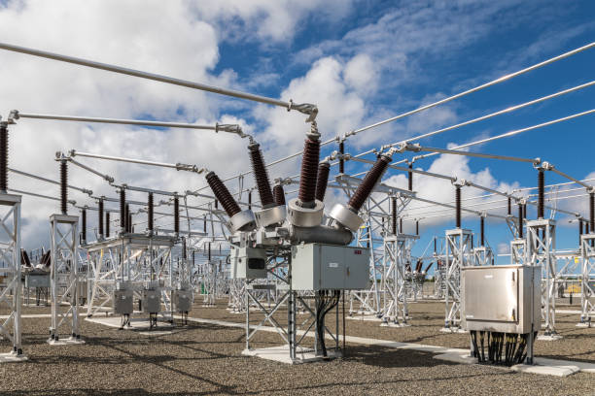

Figure 1.1 33/11 ………….

The main bus 33KV is connected to grid located at **Shohratgarh.** Now the transmission line first parallel connected with lightning arrester to diverge surge, followed by CVT connected parallel. CVT measures voltage and steeps down at 110V. A.C. for control panel, at the location a wave trap is connected to carrier communication at higher frequencies. A current transformer is connected in series with line which measure current and step down current at ratio 800:1 for control panel.

Switchgear equipment is provided, which is the combination of a circuit breaker having an isolator at each end. A transformer is connected to main bus though a bus coupler. The main bus has total capability of 10 MVA for 33 KV, which is subdivided into two transformer capacity of 10 MVA (5MVA+5MVA) parallel connected for 33KV and other two transformer capacity of 80KV (40KV+40KV) are parallel connected for substation.

At both ends of transformer lightning arrester current transformer and switchgear equipment provided. Transformer step downs voltage from **33KV to 11KV.** The main bus is provided with switchgear equipment & a current transformer. This gives way to six feeders transmitting power to **Shohratgarh.** The main bus is connected to jack bus or transfer bus through a bus coupler & 11KV is provided with switchgear equipment.

A step down transformer of 11KV/440V is connected to control panel to provide supply to the equipment’s of the substation. Capacitor bank is connected to main bus of 11KV. It is provided to improve power factor & voltage profile.

**2. Transformers**

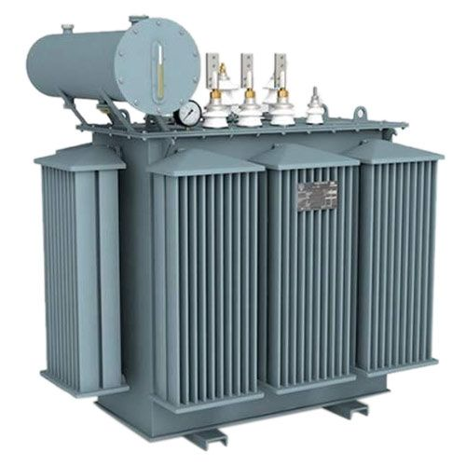

Figure: 2.1 Transformer

Transformer is a static machine, which transforms the potential of alternating current at same frequency. It means the transformer transforms the low voltage into high voltage & high voltage to low voltage at same frequency. It works on the principle of static induction principle.

When the energy is transformed into a higher voltage, the transformer is called step up transformer but in case of other is known as step down transformer.

**TYPES OF TRANSFORMER**

Power transformer

Instrument transformer

Auto transformer

On the basis of working

On the basis of structure

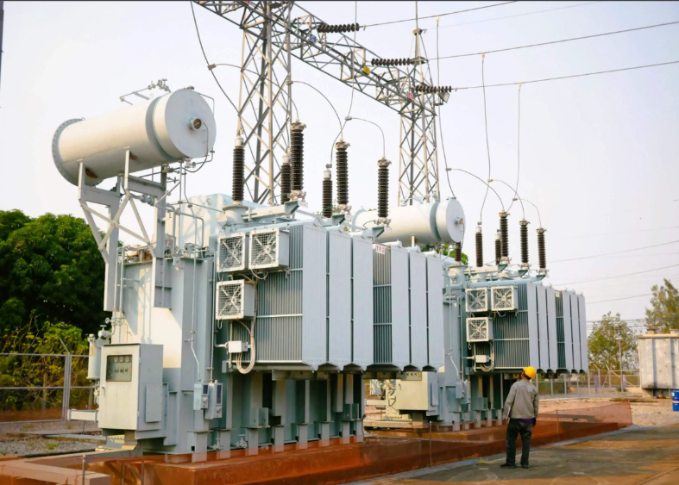**POWER TRANSFORMER:**

Figure 2.2 Power Transformers

**Types of power transformer:**

Single phase transformer

Three phase transformer

**INSTRUMENT TRANSFORMER:**

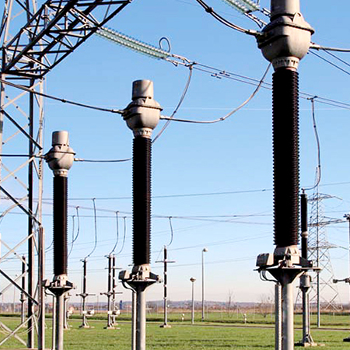

Fig: 2.3 Instrument Transformers

a) Current transformer

b) Potential transformer

**AUTO TRANSFORMER:**

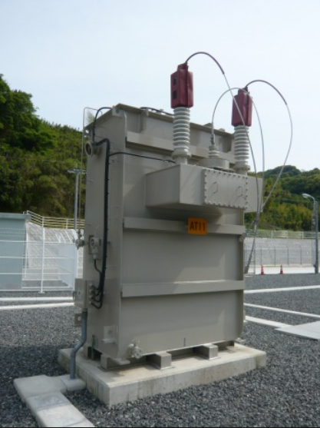

Fig 2.4 Auto Transformer

a) Single phase transformer

b) Three phase transformers

**ON THE BASIS OF WORKING**

**Step down:** Converts high voltage into low voltage.

**Step up:** Converts low voltage into high voltage.

**ON THE BASIS OF STRUCTURE**

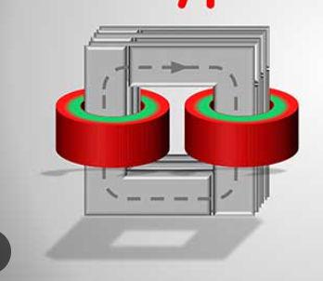

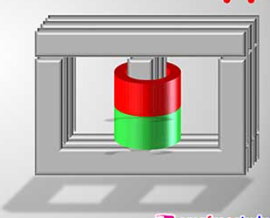

Figure 2.5 core type Figure 2.6 Shell type

**3. SPECIFICATION OF C.T. USED IN 33/11 KV, Shohratgarh**

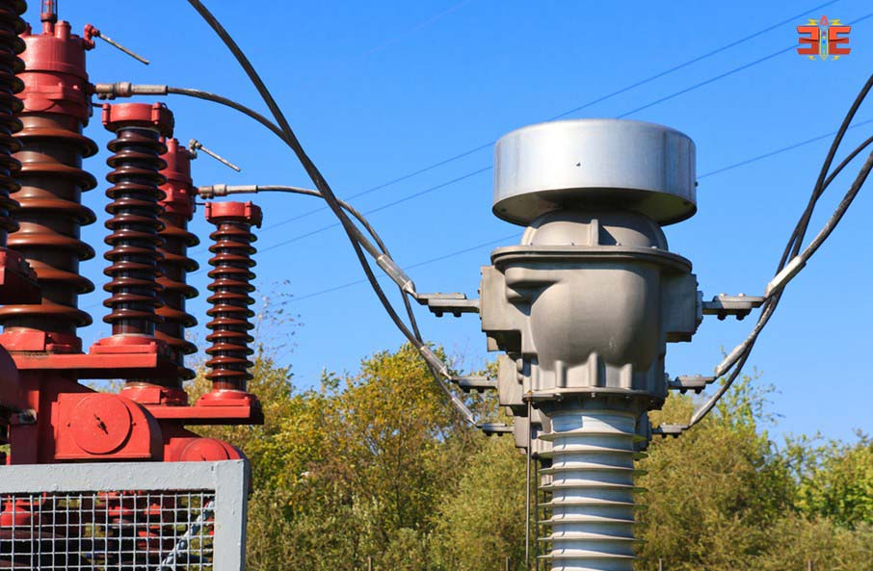

Figure 3.1 Current transformer

**Standard: IS-2785**

**Highest System Voltage: 145 KV**

**Frequency: 50Hz**

**C.T. Current: 25 KA/1Sec.**

**Rated primary current: 800 Ampere**

**4. SUBSTATIONS**

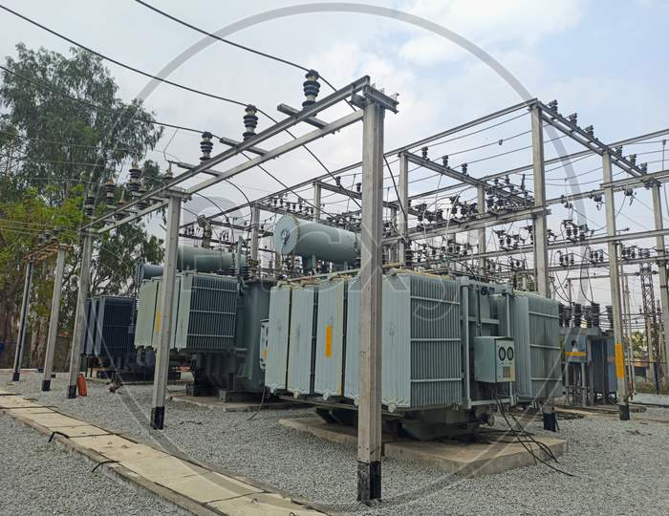

Figure 4.1 View of substation

The presentday electrical power system is A.C.i.e. electrical power is generated, transmitted & distributed in the form of the alternating current. The electric power is produced at power plant stations which are located at favorable places generally quite away from the consumers. It is delivered to the consumers through a large network of transmission 7 distribution.

At many places in the power system, it may be desirable and necessary to change some characteristics e.g. voltage, ac to de, frequency, power factor etc. of electric supply. This accomplished by suitable apparatus called substation. For example; generation voltage (33 KV or 11 KV) at the power station is set up to high voltage (say 33 KV or 11 KV) for transmission of electric power. The assembly of apparatus (e.g. transformer etc.) used for this purpose in the substation. Similarly near the consumer's localities, the voltage may have to be step down to utilization level. This job is again accomplished by suitable apparatus called substation.

The assembly of apparatus to change some characteristic of electric power supply is called substation.

The two most ways to classify substation are:-

**TYPES OF SUBSTATIONS**

**According to the service requirement:**

Transformer substation

Switch substation

Power factor connection substation

Frequency change substation

Converting substation

Industrial substation

**According to the constructional features:**

Indoor substation

Outdoor substation

Underground substation

Pole mounted substation

**TRANSFORMER SUBSTATION**

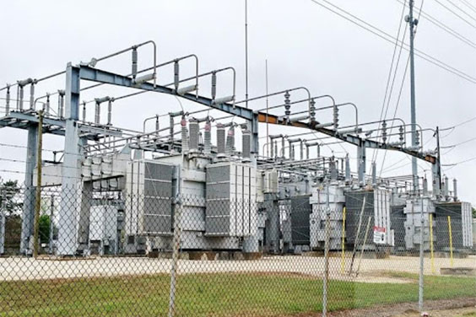

Figure 4.2 Transformer substation

They are known as transformer substations as because transformer is the main component employed to change the voltage level, depending upon the purposed served transformer substations may be classified into:

**STEP UP SUBSTATION**

The generation voltage is steeped up to high voltage to affect economy in transmission of electric power. These are generally located in the power houses and are of outdoor type.

**PRIMARY GRID SUBSTATION**

Here, electric power is received by primary substation which reduces the voltage level to 11KV for secondary transmission. The primary grid substation is generally of outdoor type.

**SECONDARY SUBSTATIONS**

At a secondary substation, the voltage is further steeped down to 11KV. The 11KV lines runs along the important road of the city. The secondary substations are also of outdoor type.

**4.1.1.1.3 DISTRIBUTION SUBSTATION**

These substations are located near the consumer's localities and step down to 400V, 3-phase, 4-wire for supplying to the consumers. The voltage between any two phases is 400V & between any phase and neutral it is 230V.

**SUBSTATION CHARACTERISTICS:**

Each circuit is protected by its own circuit breaker and hence plant outage does not necessarily result in loss of supply.

A fault on the feeder or transformer circuit breaker causes loss of the transformer and feeder circuit, one of which may be restored after isolating the faulty circuit breaker.

A fault on the bus section circuit breaker causes complete shutdown of the substation. All circuits may be restored after isolating the faulty circuit breaker. Maintenance of a feeder or transformer circuit breaker involves loss of the circuit. Introduction of bypass isolators between bus bar and circuit isolator allows circuit breaker maintenance facilities without loss of that circuit.

**STEPS IN DESIGNING SUBSTATION:**

The First Step in designing a Substation is to design an Earthing and Bonding System.

**Earthing and Bonding:**

The function of an earthing and bonding system is to provide an earthing system connection to which transformer neutrals or earthing impedances may be connected in order to pass the maximum fault current. The earthing system also ensures that no thermal or mechanical damage occurs on the equipment within the substation, thereby resulting in safety to operation and maintenance personnel. The earthing system also guarantees equipotent bonding such that there are no dangerous potential gradients developed in the substation. In designing the substation, three voltage have to be considered these are:

**Touch Voltage:**

This is the difference in potential between the surface potential and the potential at earthed equipment whilst a man is standing and touching the earthed structure.

**Step Voltage:**

This is the potential difference developed when a man bridges a distance of Im with his feet while not touching any other earthed equipment.

**Mesh Voltage:**

This is the maximum touch voltage that is developed in the mesh of the earthing grid.

**Substation Earthing Calculation Methodology**

Calculations for earth impedances, touch and step potentials are based on site measurements of ground resistivity and system fault levels. A grid layout with particular conductors is then analyzed to determine the effective substation earthing resistance, from which the earthing voltage is calculated.

In practice, it is normal to take the highest fault level for substation earth grid calculation purposes. Additionally, it is necessary to ensure a sufficient margin such that expansion of the system is catered for.

To determine the earth resistivity, probe tests are carried out on the site. These tests are best performed in dry weather such that conservative resistivity readings are obtained.

**Earthing Materials**

**4.3.3.4 Conductors:**

Bare copper conductor is usually used for the substation earthing grid. The copper bars themselves usually have a cross-sectional area of 95 square millimeters, and they are laid at a shallow depth of 0.25-0.5m, in 3-7m squares. In addition to the buried potential earth grid, a separate above ground earthing ring is usually provided, to which all metallic substation plant is bonded.

**Connections:**

Connections to the grid and other earthing joints should not be soldered because the heat generated during fault conditions could cause a soldered joint to fail. Joints are usually bolted.

**Earthing Rods:**

The earthing grid must be supplemented by earthing rods to assist in the dissipation of earth fault currents and further reduce the overall substation earthing resistance. These rods are usually made of solid copper, or copper clad steel.

**Switchyard Fence Earthing**

The switchyard fence earthing practices are possible and are used by different utilities. These are:

Extend the substation earth grid 0.5m-1.5m beyond the fence perimeter. The fence is then bonded to the grid at regular intervals. Place the fence beyond the perimeter of the switchyard earthing grid and bond the fence to its own earthing rod system. This earthing rod system is not coupled to the main substation earthing grid.

**CONDUCTORS USED IN SUBSTATION DESIGN:**

An ideal conductor should fulfills the following requirements:

Should be capable of carrying the specified load currents and short time currents. Should be able to withstar d forces on it due to its situation. These forces comprise self weight, and weight of other conductors and equipment, short circuit forces and atmospheric forces such as wind and ice loading.

Should be corona free at rated voltage.

Should have the minimum number of joints,

Should need the minimum number of supporting insulators.

Should be economical.

The most suitable material for the conductor system is copper or aluminums. Steel may be used but has limitations of poor conductivity and high susceptibility to corrosion.

In an effort to make the conductor ideal, three different types have been utilized, and these include: Flat surfaced Conductors, Stranded Conductors, and Tubular Conductors

**Overhead Line Terminations**

Two methods are used to terminate overhead lines at a substation.

Tensioning conductors to substation structures or buildings.

Tensioning conductors to ground winches.

The choice is influenced by the height of towers and the proximity to the substation. The following clearances should be observed:

|  |  |
| --- | --- |
| **VOLTAGE LEVEL** | **MINIMUM GROUND CLEARANCE** |
| less than 11kV | 6.1m |
| 11KV-20kV | 6.4m |
| 20kV-30kV | 6.7m |
| greater than 30kV | 7.0m |

Table 1 Clearance in accordance with voltage value

**5. CHRONOLOGICAL TRAINING DIARY**

**(based on study & observation at different Departments and sections)**

**POWER LINE CARRIER COMMUNICATION**

**Introduction:**

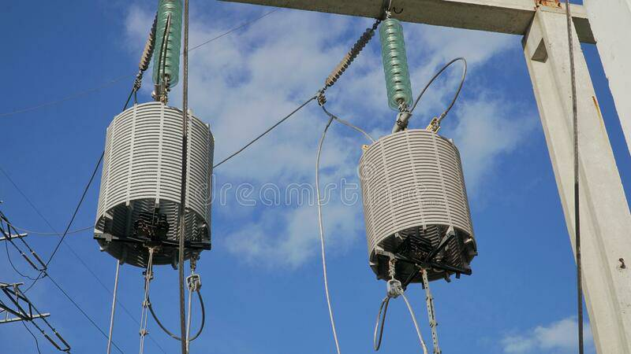

Figure 5.1: PLCC (POWER LINE CARRIER COMMUNICATION)

Reliable & fast communication is necessary for safe efficient & economical power supply. To reduce the power failure in extent & time, to maintain the interconnected grid system in optimum working condition: to coordinate the operation of various generating unit communication network is indispensable for state electricity board.

In state electricity boards, the generating & distribution stations are generally located at a far distance from cities. Where P & T communication provided through long overhead lines in neither reliable nor quick.

As we have available very reliable physical paths viz. the power lines, which interconnected, hence power line carrier communication is found to be most economical and reliable for electricity boards.

**APPLICATIONS:**

The PLCC can be used for the following facilities:

Telephony

Teleprotection

Remote control or indication

Telemetry

Teleprinting

**PRINCIPLE OF PLCC:**

The principle of PLCC is the simple one:0

All type of information is modulated on carried wave at frequency 50Hz to 500 KHz. The modulated HF carrier fed into the power line conductor at the sending end and filtered out again at the respective stations. Long earlier system double side band amplitude modulation was more common but the present amplitude modulated system.

Since high voltage power lines are designed to carry large quantities of energy on the high voltage and the communication system at low voltage, they cannot be directly connected to high voltage lines. Suitably designed coupling equipments have therefore to be employed which will permit the injection of high frequency carrier signal without undue loss and with absolute protection of communication equipments or operating personal from high voltage hazard.

Therefore, the coupling equipment essentially comprises the following:

**Wave trap or line trap:**

Wave trap is connected in series with power line between the point of connection of coupling capacitor and S/S. Wave trap offers negligible impedance to HF carrier. Wave trap stands electromechanically and thermally for short circuit current in the event of fault on the line. On the basis of blocking frequency bank, the wave trap can be following type:

ALL WAVE

SINGAL FREQUENCY

DOUBLE FREQUENCY

BROAD BAND

**Coupling capacitor:**

The modulated carrier is let into power line through coupling capacitor specially designed to with stand line voltage under all weather condition. The upper end of the coupling capacitor is connected directly to the line and the lower end is connected to the ground through a carrier frequency chock coil or drain coil. Thus coupling capacitor forms the link between the PLCC equipment and power line. The coupling capacitor used in UPSEB is 2200pf capacitance.

The coupling capacitor are designed for outdoor use and hence to withstand normal atmospheric phenomenon such as temperature & humidity changes, rain, snow, anticipated wind load, nominal wire tension etc. at full rated voltage. In some case capacitive voltage transformers (CVT) used as a source of line voltage for metering and protection as also used coupling capacitor for PLCC.

**Protective Device of Coarse Voltage Arrester:**

This is connected across the primary of the coupling filter i.e. one end is connected to the bottom of the coupling capacitor and other end is earthed. This is provided to protect the coupling filter against line surges. An air gap is provided, where voltage of the order of 1.8 to 2KV as observed across due to lighting etc. on line.

**Coupling of Filter:**

The coupling filter is inserted between the low voltage terminal of the coupling capacitor and the carrier frequency connection of the carrier terminal. Some time an earth switch is also provided with this unit. This unit mainly performs two functions: firstly it isolates the connection of equipment from the power line. Secondly it serves to match characteristic impedance of the power line to that of the H.F. cable to connection equipments.

**H.F. Cable:**

H.F. cable normally used to connect the coupling filter to another coupling terminal. The cable is insulated to withstand the test voltage of 4KV. The impedance of this H.F. cable is so as to match with the output of the PLCC terminal and secondary impedance of coupling filter.

**TYPES OF COUPLING:**

The following three types of coupling are being used in UPSEB depending on the requirement:

Phase to ground coupling

Phase to phase coupling

Internal coupling

**COUPLING LOSSES:**

Composite loss

Tapping loss

H.F. cable loss

Additional loss

**6. BUSBARS**

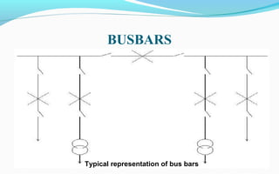

Figure 6.1 Typical representation of bus bars

When numbers of generators or feeders operating at the same voltage have to be directly connected electrically, bus bar is used as the common electrical component. Bus bars are made up of copper rods operate at constant voltage. The following are the important bus bars arrangements used at substations:

Single bus bar system

Single bus bar system with section alisation

Duplicate bus bar system

In large stations it is important that break downs and maintenance should interfere as little us possible with continuity of supply to achieve this, duplicate bus bar system is used. Such a system consists of two bus bars, a main bus bar and a spare bas bar with the help of bus coupler. which consist of the circuit breaker and isolator.

In substations, it is often desired to disconnect a part of the system for general maintenance and repairs. An isolating switch or isolator accomplishes this. Isolator operates under no load condition. It does not have any specified current breaking capacity or current making capacity. In some cases isolators are used to breaking charging currents or transmission lines.

While opening a circuit, the circuit breaker is opened first then isolator while closing a circuit the isolator is closed first, then circuit breakers. Isolators are necessary on supply side of circuit breakers, in order to ensure isolation of the circuit breaker from live parts for the purpose of maintenance.

A transfer isolator is used to transfer main supply from main bus to transfer bus by using bus coupler (combination of a circuit breaker with two isolators), if repairing or maintenance of any section is required.

**7. INSULATORS**

The insulator serves two purposes. They support the conductors (bus bar) and confine the current to the conductors. The most common used material for the manufacture of insulator is porcelain. There are several types of insulators (eg pin type, suspension type, post insulator etc.) and their use in substation will depend upon the service requirement. For example, post insulator is used for bus bars. A post insulator consists of a porcelain body, cast iron cap and flanged cast iron base. The hole in the cap is threaded so that hus bars can be directly bolted to the cap.

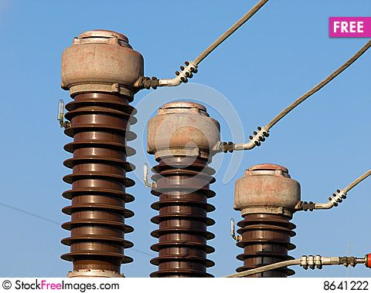

Figure 7.1 Insulators used in substations

With the advantage of power system, the lines and other equipment operate at very high voltage and carry high current.

The arrangements of switching along with switches cannot serve the desired function of switchgear in such high capacity circuits. This necessitates employing a more dependable means of control such as is obtain by the use of the circuit breakers. A circuit breaker can make or break a circuit either manually or automatically under all condition as no load, full load and short circuit condition.

A circuit breaker essentially consists of fixed and moving contacts. These contacts can be opened manually or by remote control whenever desired. When a fault occurs on any part of the system, the trip coils of breaker get energized and the moving contacts are pulled apart by some

mechanism, thus opening the circuit.

When contacts of a circuit breaker are separated, an are is struck; the current is thus able to continue. The production of ares are not only delays the current interruption, but is also generates the heat. Therefore, the main problem is to distinguish the are within the shortest possible time so that it may not reach a dangerous value.

The general way of classification is on the basis of the medium used for are extinction.

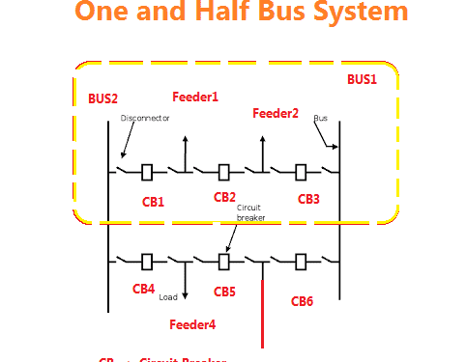

Figure 7.2 Circuit breaker arrangements

**Circuit breakers**

They can be classified into:

**Oil circuit breaker**

Air-blast circuit breaker

**Sulphar hexafluoride circuit breaker (SF)**

**Vacuum circuit breakers**

**Note:** SF, and Vacuum circuit breaker are being used in 33KV distribution substation.

**Oil Circuit Breaker**

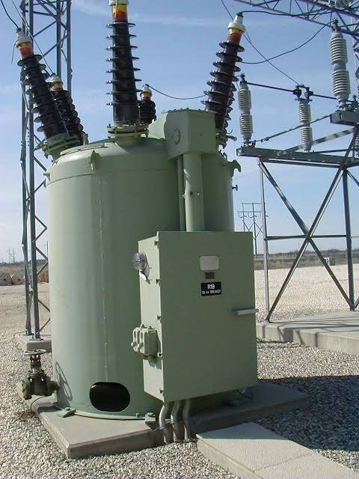

Figure 7.3 Oil circuit breaker

A high-voltage circuit breaker in which the arc is drawn in oil to dissipate the heat and

extinguish the arc; the intense heat of the arc decomposes the oil, generating a gas whose high pressure produces a flow of fresh fluid through the arc that furnishes the necessary insulation to prevent a restrike of the are.

The arc is then extinguished, both because of its elongation upon parting of contacts and because of intensive cooling by the gases and oil vapor.

**Air blast circuit breaker**

Fast operations, suitability for repeated operation, auto reclosure, unit type multi break constructions, simple assembly, modest maintenance are some of the main features of air blast circuit breakers. A compressors plant necessary to maintain high air pressure in the air receiver. The air blast circuit breakers are especially suitable for railways and are furnaces, where the breaker operates repeatedly. Air blast circuit breakers is used for interconnected lines and important lines where rapid operation is desired.

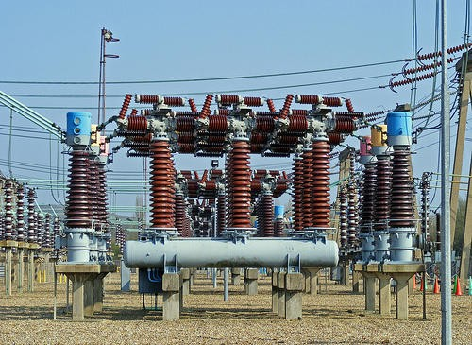

Figure 7.4 Air blast circuit breaker

High pressure air at a pressure between 20 to 30 kg/cm2 stored in the air reservoir. Air is taken from the compressed air system. Three hollow insulator columns are mounted on the reservoir with valves at their basis. The double are extinguished chambers are mounted on the top of the hollow insulator chambers. The current carrying parts connect the three are extinction. chambers to each other in series and the pole to the neighboring equipment. Since there exists as very high voltage between the conductor and the air reservoir, the entire are extinction chambers assembly is mounted on insulators.

**SF6 CIRCUIT BREAKER:**

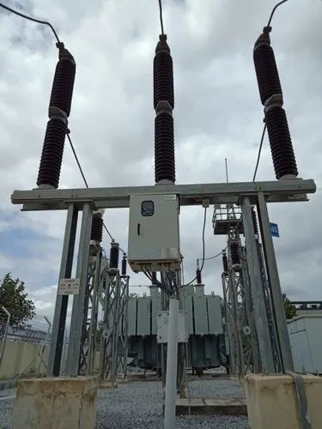

Figure 7.5 SF6 Circuit breaker

In such circuit breaker, sulphar hexafluoride (SF) gas is used as the arc quenching medium. The SF is an electronegative gas and has a strong tendency to absorb free electrons. The SF circuit breaker have been found to a very effective for high pewer and high voltage service. SF, circuit breakers have been developed for voltage 115 KV to 230 KV. power rating 10 MVA.

It consists of fixed and moving contacts. It has chamber, contains SF gas. When the contacts are opened, the mechanism permits a high pressure SF. gas from reservoir to flow towards the arc interruption chamber. The moving contact permits the SF, gas to let through these holes.

**Vacuum Circuit Breaker**

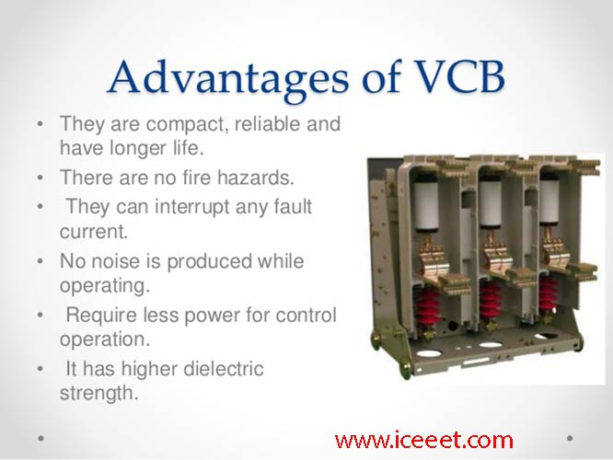

Figure 7.6 Vacuum circuit breaker

Vacuum circuit breakers are circuit breakers which are used to protect medium and high voltage circuits from dangerous electrical situations. Like other types of circuit breakers, vacuum circuit breakers literally break the circuit so that energy cannot continue flowing through it. thereby preventing fires, power surges, and other problems which may emerge. These devices have been utilized since the 1920s, and several companies have introduced refinements to make them even safer and more effective.

**Rating of 132 KV SF, circuit breaker:**

Breaking current: 50A

Making capacity: 80KA

Total break time < 60msec)

Rated short circuit breaking current:

Symmetrical: 31.5 KA

Asymmetrical: 36.86 KA

Rated duration of short circuit current: 3sec

Rated rominal current: 1250 A

Rated voltage: 145 KV

Rated SF, gas pressure: 6 KG

**8. METERING AND INDICATION EQUIPMENT**

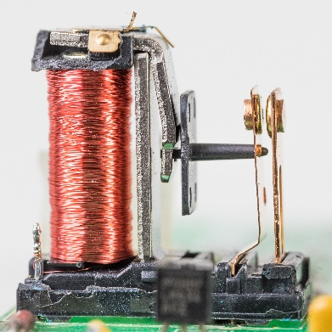**RELAY:**

Figure 8.1 Relay

In a power system it is inevitable that immediately or later some failure does occur somewhere in the system. When a failure occurs on any part of the system, it must be quickly detected and disconnected from the system. Rapid disconnection of faulted apparatus limits the amount of damage to it and prevents the effects of fault from spreading into the system. For high voltage circuits relays are employed to serve the desired function of automatic protective gear. The relays detect the fault and supply the information to the circuit breaker.

The electrical quantities which may change under fault condition are voltage, frequency. current, phase angle. When a short circuit occurs at any point on the transmission line the current flowing in the line increases to the enormous value. This result in a heavy current flow through the relay coil, causing the relay to operate by closing its contacts. This in turn closes the trip circuit of the breaker making the circuit breaker open and isolating the faulty section from the rest of the system. In this way, the relay ensures the safety of the circuit equipment from the damage and normal working of the healthy portion of the system. Basically relay work on the following two main operating principles:

**Electromagnetic attraction relay**

**Electromagnetic induction relay**

**Relays used in control panel of the substation;**

**DIFFERENTIAL RELAY:**

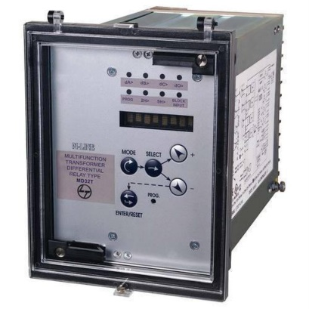

Figure 8.2 Differential Relay

A differential relay is one that operates when vector difference of the two or more electrical quantities exceeds a predetermined value. If this differential quantity is equal or greater than the pickup value, the relay will operate and open the circuit breaker to isolate the faulty section.

**OVER CURRENT RELAY:**

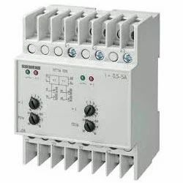

Figure 8.3 Overcurrent Relay

This type of relay works when current in the circuit exceeds the predetermined value. The actuating source is the current in the circuit supplied to the relay from a current transformer. These relay are used on A.C. circuit only and can operate for fault flow in the either direction. This relay operates when phase to phase fault occurs.

**DIRECTIONAL RELAY:**

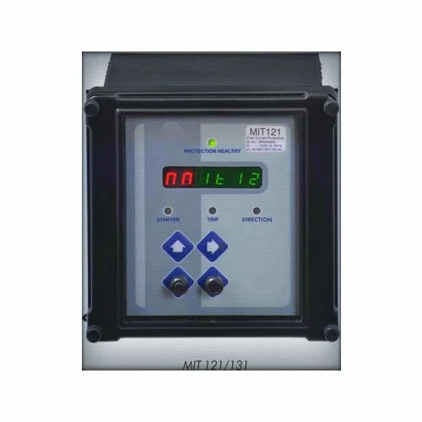

Figure8.4 Directional Relay

This relay operates during earth faults. If one phase touch the earth due to any fault. A directional power relay is so designed that it obtains its operating torque by the interaction of magnetic field derived from both voltage and current source of the circuit it protects. The direction of torque depends upon the current relative to voltage.

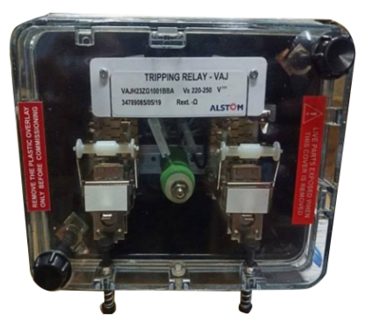**TRIPPING RELAY:**

Figure 8.5 Tripping Relay

This type of relay is in the conjunction with main relay. When main relay sense any fault in the system, it immediately operates the trip relay to disconnect the faulty section from the section

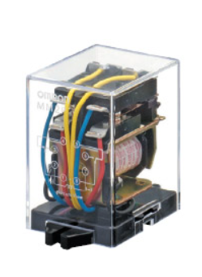**AUXILIARY RELAY:**

Figure 8.6 Auxiliary Relay

An auxiliary relay is used to indicate the fault by glowing bulb alert the employee.

**9. MISCELLANOUS EQUIPMENT**

**CAPACITOR BANK:**

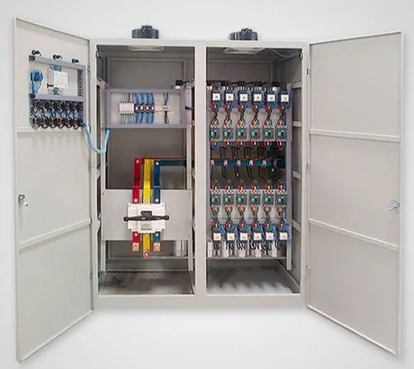

Figure 9.1 Capacitor bank

The load on the power system is varying being high during morning and evening which increases the magnetization current. This result in the decreased power factor. The low power factor is mainly due to the fact most of the power loads are inductive and therefore take lagging currents. The low power factor is highly undesirable as it causes increases in current, resulting in additional losses. So in order to ensure most favorable conditions for a supply system from engineering and economical stand point it is important to have power factor as close to unity as possible. In order to improve the power factor come device taking leading power should be connected in parallel with the load. One of the such device can be capacitor bank. The capacitor draws a leading current ard partly or completely neutralize the lagging reactive component of load current.

**Capacitor bank accomplishes following operations:**

Supply reactive power

Increases terminal voltage

Improve power factor

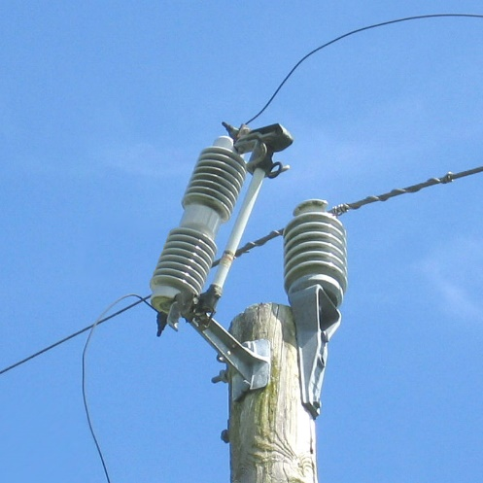**FUSE:**

Figure 9.2 Substation Fuse

A fuse is a short piece of wire or thin strip which melts when excessive current through it for sufficient time. It is inserted in series with the circuit under normal operating conditions; the fuse element is at a nature below its melting point. Therefore it carries the normal load current overheating. It is worthwhile to note that a fuse performs both detection and interruption ( functions.

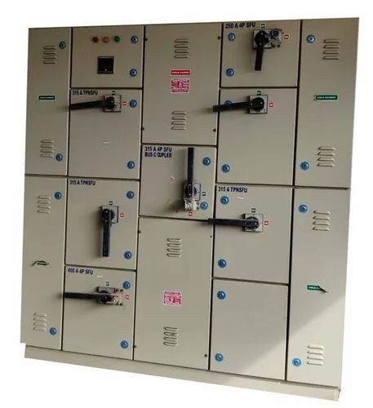**BUS COUPLER:**

Figure 9.3 bus coupler

The bus coupler consists of circuit breaker and isolator. Each generator and feeder may be connected to either main bus bar or spar bus bar with the help of bus coupler. Repairing, maintenance and testing of feeder circuit or other section can be done by putting them on spar bus bar, thus keeping the main bus bar undisturbed.

**10. PROTECTION OF SUBSTATION:**

**Transformer protection:**

Transformers are totally enclosed static devices and generally oil immersed. Therefore chances of fault occurring on them are very easy rare, however the consequences of even a rare fault may be very serious unless the transformer is quickly disconnected from the system. This provides adequate automatic protection for transformers against possible faults.

**Conservator and Breather:**

When the oil expands or contacts by the change in the temperature, the oil level goes either up or down in main tank. A conservator is used to maintain the oil level up to predetermined value in the transformer main tank by placing it above the level of the top of the tank.

Breather is connected to conservator tank for the purpose of extracting moisture as it spoils the insulating properties of the oil. During the contraction and expansion of oil air is drawn in or out through breather silica gel crystals impregnated with cobalt chloride. Silica gel is

checked regularly and dried and replaced when necessary.

**Marshalling box:**

It has two meter which indicate the temperature of the oil and winding of main tank. If temperature of oil or winding exceeds than specified value, relay operates to sound an alarm. If there is further increase in temperature then relay completes the trip circuit to open the circuit breaker controlling the transformer.

**Transformer cooling:**

When the transformer is in operation heat is generated due to aron losses the removal of heat is called cooling.

There are several **types of cooling methods,** they are as follows:

**Air natural cooling:**

In a dry type of self cooled transformers, the natural circulation of surrounding air is used for its cooling. This type of cooling is satisfactory for low voltage small transformers.

**Air blast cooling:**

It is similar to that of dry type self cooled transformers with to addition that continuous blast of filtered cool air is forced through the core and winding for better cooling. A fan produces the blast.

**Oil natural cooling:**

Medium and large rating have their winding and core immersed in oil, which act both as a cooling medium and an insulating medium. The heat produce in the cores and winding is passed to the oil becomes lighter and rises to the top and place is taken by cool oil from the bottom of the cooling tank.

**Oil blast cooling:**

In this type of cooling, forced air is directed over cooling elements of transformers immersed in oil.

Forced oil and forced air flow (OFB) cooling:

Oil is circulated from the top of the transformers tank to a cooling tank to a cooling plant. Oil is then returned to the bottom of the tank.

**Forced oil and water (OWF) cooling:**

In this type of cooling oil flow with water cooling of the oil in external water heat exchanger takes place. The water is circulated in cooling tubes in the heat exchanger.

**11. CONCLUSION**

Now from this report we can conclude that electricity plays an important role in our life. We are made aware of how the transmission of electricity is done. We too came to know about the various parts of the Substation system.

The **Uttar Pradesh Cooperation Limited** has got radio communication in microwave range in order to transmit and receive data with various Substations in Uttar Pradesh to get reliable transmission and distribution of electricity.

**References**

1. [www.yahooanswers.com](http://www.yahooanswers.com)

2. [www.britannica.com](http://www.britannica.com)

3. [www.webopedia.com](http://www.webopedia.com)

4. [www.encyclopedia.com](http://www.encyclopedia.com)

5. [www.worldbook.com](http://www.worldbook.com)

6. [www.encyclopediadramatica.com/](http://www.encyclopediadramatica.com/)